CI/CD Pipeline

**PREPARED FOR**

Erik van der Schriek

Niko Kuijpers

Gertjan Schouten

**PREPARED BY**

Maarten Blömer

Nick Krijgsman

Faruk Aydin

Jursley Gonzalez

Vincent Andersen

# Table of Contents

**Table of Contents** **1**

**CI/CD Pipeline** **2**

# CI/CD Pipeline

The following image shows the full build of the project. Small changes have been made, due to running out of credits on the azure cloud we are not able to access it anymore.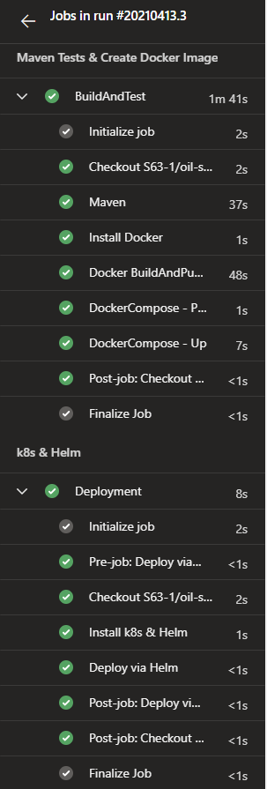

As seen on the image to the left; our project starts with running the tests built into our spring boot microservices. Once these tests are successfully passed, Docker is installed on the VM. Docker then takes care of building the image of the microservice, adds it to the docker compose for the whole project.

The deployment part will install kubernetes and helm. Helm does the heavy lifting of running the docker compose inside the kubernetes cluster.

As a solution to the azure credits running out we have built a similar structure for our local machine and the fontys seclab. We have a docker compose file where all our configuration is written for the whole application. To make sure that all our docker images are up to date we use Jib to build the docker images on each push. Using Kompose from kubernetes we translate it into kubernetes deployment, and service files. This allows us to run the kubectl commands to run the application.